
Procedure for the Management
of Nonconformity
ISO22301 Toolkit: Version 6
©CertiKit

Implementation guidance
The header page and this section, up to and including Disclaimer, must be removed from the final version of the document. For more details on replacing the logo, yellow highlighted text and certain generic terms, see the Completion Instructions document.

Purpose of this document
This document describes the way in which nonconformities will be identified, logged and managed to resolution.

Areas of the standard addressed
The following areas of the ISO22301 standard are addressed by this document:
- 10. Improvement
  - 10.1 Nonconformity and corrective action

General guidance
It may take some time to fully understand what a “nonconformity” is, particularly as the ISO definition is so wide-ranging. From an auditor’s viewpoint, a nonconformity represents an instance where the established way of doing things has not been followed or has been found not to work correctly. For example, this may be due to someone not following a procedure or perhaps a procedure being wrong and therefore not having the desired effect.
We would recommend taking a wide view of what should be logged as a nonconformity initially and then fine-tuning it based on your own experience and the advice of your auditor.

Review frequency
We would recommend that this document is reviewed annually.

Document fields
This document may contain fields which need to be updated with your own information, including a field for Organization Name that is linked to the custom document property “Organization Name”.
To update this field (and any others that may exist in this document):
- Update the custom document property “Organization Name” by clicking File > Info > Properties > Advanced Properties > Custom > Organization Name.
- Press Ctrl A on the keyboard to select all text in the document (or use Select, Select All via the Editing header on the Home tab).
- Press F9 on the keyboard to update all fields.
- When prompted, choose the option to just update TOC page numbers.
If you wish to permanently convert the fields in this document to text, for instance, so that they are no longer updateable, you will need to click into each occurrence of the field and press Ctrl Shift F9.
If you would like to make all fields in the document visible, go to File > Options > Advanced > Show document content > Field shading and set this to “Always”. This can be useful to check you have updated all fields correctly.
Further detail on the above procedure can be found in the toolkit Completion Instructions. This document also contains guidance on working with the toolkit documents with an Apple Mac, and in Google Docs/Sheets.

Copyright notice
Except for any specifically identified third-party works included, this document has been authored by CertiKit, and is ©CertiKit except as stated below. CertiKit is a company registered in England and Wales with company number 6432088.

Licence terms
This document is licensed on and subject to the standard licence terms of CertiKit, available on request, or by download from our website. All other rights are reserved. Unless you have purchased this product you only have an evaluation licence.
If this product was purchased, a full licence is granted to the person identified as the licensee in the relevant purchase order. The standard licence terms include special terms relating to any third-party copyright included in this document.

Disclaimer
Please Note: Your use of and reliance on this document template is at your sole risk. Document templates are intended to be used as a starting point only from which you will create your own document and to which you will apply all reasonable quality checks before use.
Therefore, please note that it is your responsibility to ensure that the content of any document you create that is based on our templates is correct and appropriate for your needs and complies with relevant laws in your country.
You should take all reasonable and proper legal and other professional advice before using this document.
CertiKit makes no claims, promises, or guarantees about the accuracy, completeness or adequacy of our document templates; assumes no duty of care to any person with respect its document templates or their contents; and expressly excludes and disclaims liability for any cost, expense, loss or damage suffered or incurred in reliance on our document templates, or in expectation of our document templates meeting your needs, including (without limitation) as a result of misstatements, errors and omissions in their contents.



Procedure for the Management
of Nonconformity

DOCUMENT REF | BCMS-DOC-10-1
VERSION | 1
DATED | [Insert date]
DOCUMENT AUTHOR | [Insert name]
DOCUMENT OWNER | [Insert name/role]

Revision history
VERSION | DATE | REVISION AUTHOR | SUMMARY OF CHANGES

Distribution
NAME | TITLE

Approval
NAME | POSITION | SIGNATURE | DATE

Contents
1 Introduction 8
2 Nonconformity management procedure 9
2.1 Identifying nonconformities 10
2.2 Add to nonconformity and corrective action log 10
2.3 React to the nonconformity 10
2.4 Cause determination 10
2.5 Assess potential impact 11
2.6 Implement corrective action 11
2.7 Review effectiveness of corrective action 11
2.8 Amend BCMS if necessary 12

Figures
Figure 1: Nonconformity management procedure 9

Introduction
This procedure describes the steps to be taken when a nonconformity is found within the Business Continuity Management System (BCMS). A nonconformity is defined by ISO as the “non-fulfilment of a requirement”.
This is a wide definition which basically means that the BCMS is not succeeding in its purpose, which is to fulfil the business continuity requirements of the organization. A nonconformity may arise for many reasons, in many forms and from many different sources. The purpose of this procedure is to ensure that they are recorded when they are identified and that the appropriate steps are taken to ensure that the immediate and wider actual and potential impacts of the nonconformity are addressed.
In addition to internal and external audits, nonconformities may be identified from the day-to-day performance of procedures, management meetings and communication with suppliers, customers and other interested parties.
To understand the purpose and objectives of the BCMS, the following documents may be referenced:
- Business Continuity Context, Requirements and Scope
- Business Continuity Policy

Nonconformity management procedure
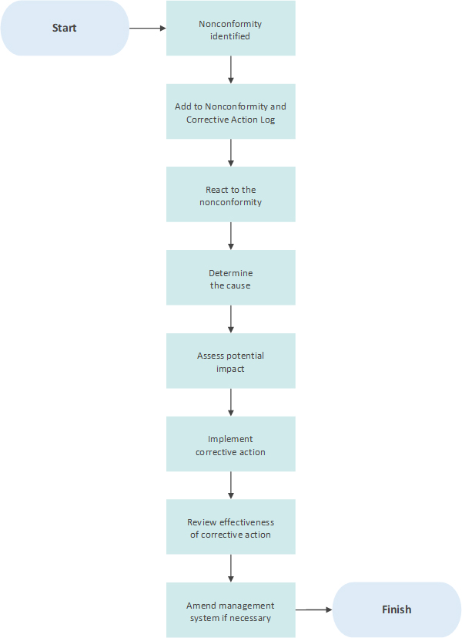
Figure 1: Nonconformity management procedure
The detail of the steps on the previous page is described in the following sections.

Identifying nonconformities
Nonconformities may be identified from any source and the Business Continuity Manager will encourage staff, users, customers and suppliers to propose ways in which they can be addressed.
Such nonconformities may be identified from:
- Business process reviews
- Team meetings
- Supplier meetings
- Risk assessments
- User surveys
- Internal and external audits
However, the above is not an exhaustive list.

Add to nonconformity and corrective action log
Once identified, the nonconformity will be documented within the Nonconformity and Corrective Action Log with a status of “Open”. At this stage, the action to correct the nonconformity has not necessarily been determined. As much detail as possible should be specified as to the exact nature of the nonconformity.

React to the nonconformity
If action needs to be taken to address the nonconformity immediately then this should be done without delay. This may be to fix it, stop it from getting worse or to reduce its effects until further action may be taken. Appropriate resources should be allocated to addressing the nonconformity depending on the current assessment of its seriousness.
Actions taken should be recorded in the action log, with dates.

Cause determination
Once logged and initial reactive actions put in place, the nonconformity will be evaluated to assess its underlying cause i.e. why it has arisen. Other parties may be consulted during this stage to understand the mechanism and events leading to the nonconformity.

The identified cause should be recorded in the action log with as much description as appropriate.

Assess potential impact
Once the cause is understood, a review should be undertaken to assess whether similar nonconformities already exist elsewhere within the BCMS and whether they could potentially arise in the future.
The findings of this review should be recorded in the action log.

Implement corrective action
Once the cause and real or potential impact has been established, appropriate corrective action should be identified to address both the current situation and potential future impact of the nonconformity. The expected benefits of correcting the nonconformity should be sufficient to justify the resources required to achieve the corrective action.
The details of the corrective action to be taken should be recorded in the action log, along with the timescale and person responsible. Dated progress updates should also be added when appropriate.
Once corrective action has been completed the status of the nonconformity record within the Nonconformity and Corrective Action Log should be updated to “Review Pending” and the date of closure recorded.

Review effectiveness of corrective action
After a reasonable period of time (which will depend on the nature of the nonconformity and the corrective action) the effectiveness of the corrective action should be reviewed to assess whether it has fixed the issue, including its actual and potential impacts.
If the benefits expected are not achieved, the reasons for this will be investigated as part of the regular management review meeting.
If successful, the date and results of the review will be recorded, and the status of the nonconformity will be updated to “Closed”.

Amend BCMS if necessary
If the nonconformity is judged to have occurred due to a fault in the BCMS, it may be necessary to amend the BCMS itself, including any relevant policies, procedures and forms. This should be done with the agreement of top management.

